**DUYTAN UNIVERSITY**

**INTERNATIONAL SCHOOL**

**--------------ÐÑ¶ÐÑ-------------**



**CMU-SE 100**

**INTRODUCTION TO SOFTWARE ENGINEERING**

**SYNTHESIS REPORT GROUP PROJECT**



**Mentor:  Msc. Huy Nguyen Dang Quang**

***Team Member*:**

**Quang, Dang Nguyen Nhat**

**Huy, Pham Quoc**

**Kiet, Nguyen Quang**

**Nhan, Tran Phuoc**

**Huy, Nguyen Bao**

**Group Project - Mentor:**

Name Signature  Date

**PROJECT INFORMATION**

|  |  |  |  |  |
| --- | --- | --- | --- | --- |
| **Project Acronym** | FMS |  |  |  |
| **Project Title** | Phần mềm chọn menu, tính tiền và quản lí chuổi cửa hàng kfc | | | |
| **Start Date** | 03 – Sep – 2023 | **End Date** | 26 – Sep – 2023 | |
| **Lead Institution** | International School, Duy Tan University | | | |
| **Team Member** | **Name** | **Email** | | **Phone** |
| 29211144786 | Dang Nguyen Nhat Quang | quangquang04012005@gmail.com | | 0379627472 |
| 29211121546 | Nguyen Quang Kiet | ngqkiet121205@gmail.com | | 0932513650 |
| 29211159036 | Pham Quoc Huy | huyphamm1811@gmail.com | | 0382286691 |
| 29211159621 | Tran Phuoc Nhan | nhantran22468@gmail.com | | 0934983971 |
| 29211154038 | Nguyen Bao Huy | hymail90299029@gmail.com | | 0377180834 |

**DOCUMENT NAME**

|  |  |  |  |
| --- | --- | --- | --- |
| **Document Title** | **Synthesis Report Group Project Document** | | |
| **Reporting Period** | 26 – Sep – 2023 | | |
| **Author(s)** | Dang Nguyen Nhat Quang  Nguyen Quang Kiet  Pham Quoc Huy  Tran Phuoc Nhan  Nguyen Bao Huy | | |
| **Role** | Team leader  Team Member  Team Member  Team Member  Team Member | | |
| **Date** | 05 – Sep – 2023 | **Filename** |  |

**SIGNATURE**

***Document Approvals:*** *The following signatures are required for approval of this document.*

|  |  |  |  |
| --- | --- | --- | --- |
| **Mentor** | Huy, Nguyen Dang Quang | **Signature:** |  |
| **Date:** |  |
| **Team Lead** | Quang, Dang Nguyen Nhat | **Signature:** |  |
| **Date:** |  |
| **Team member(s)** | Kiet, Nguyen Quang | **Signature:** |  |
| **Date:** |  |
| Huy, Pham Quoc | **Signature:** |  |
| **Date:** |  |
| Nhan, Tran Phuoc | **Signature:** |  |
| **Date:** |  |
| Huy, Nguyen Bao | **Signature:** |  |
| **Date:** |  |

**REVISION HISTORY**

|  |  |  |
| --- | --- | --- |
| **Version** | **Date** | **Description** |
| **1.0** | 3/12/2023 | **Make Synthesis Report Group Project Document** |
| **1.1** | 9/12/2023 | Abc |
| **1.2** | 10/12/2023 | **Làm phần 1** |

**TABLE OF CONTENTS**

**1. INTRODUCTION**

*Restaurant name: Kentucky Fried Chicken (aka: KFC)*

*Address: 148 Nguyen Van Linh Street, Nam Duong Ward, Hai Chau District, Da Nang .*

*Hotline:* [19006886.](tel:19006886)

*Business field: Specializing in fried and grilled chicken, along with side dishes and sandwiches, hamburgers made from fresh chicken meat*

*Opening hours: 10:30 AM - 23:45 PM*

*Google reviews: 3.7/5.*

**2. DESCRIBE BUSINESS PROCESSES OF RESTAURANT**

The main business process in a KFC restaurant must meet the following requirements:

* Speed: The process must be carried out quickly to meet the needs of customers.
* Quality: The process must ensure the quality of the products and services.
* Customer satisfaction: The process must be designed to bring customer satisfaction.

**Detailed process:**

1. Welcome guests:

When customers enter the restaurant, the waiter will open the door to welcome and guide them to the order counter.

The waiter needs to show enthusiasm, friendliness, and attentiveness to create a good impression for customers.

1. Place an order:

At the order counter, customers will see the menu and order food and drinks. The waiter needs to advise customers on the food and drinks of the restaurant so that customers can choose the dishes that are suitable for their preferences and needs.

Then, the waiter will remember the dishes that the customer has chosen and enter them into the system. The system will display the dishes that the customer has ordered on the screen along with the total cost of the meal.

1. Payment:

The waiter will announce the total amount the customer must pay. Customers can pay by cash or online payment method. The waiter needs to quickly process the payment so that customers do not have to wait long.

After payment is completed, the waiter will print the payment receipt and send it to the customer (send the receipt and change when the customer pays in cash).

1. Cooking:

After receiving the order, the kitchen staff will start cooking the food. Then, the staff will prepare the drink according to the customer's request. The dishes must ensure quality and delicious taste.

The kitchen staff needs to pay attention to food safety in the cooking process. The cooking process must be fast so that customers do not have to wait long.

1. Serving food:

When the food is cooked, the waiter will bring the food to the food receiving counter and notify the customer.

The customer who receives the notification from the staff will go to the food receiving counter to get the food. Customers can request additional knives, forks, etc. at the counter.

The waiter also needs to pay attention to the presentation of the food in a beautiful and neat manner, and prepare enough knives, forks, spoons, and paper towels.

1. Cleaning tables and chairs after customers have finished eating:

After customers have finished their meal, the waiter will clean the table and chairs. The tables will be prepared to welcome the next customers.

The waiter needs to quickly clean the table so that customers can leave conveniently.

**3. LIST OF PARTICIPANTS TO REQUIREMENTS GATHERING**

- Customer eating at the restaurant (Quang)

- Receptionist

- Kitchen Staff

- Restaurant Manager

**4. THE TECHNICALS USING TO REQUIREMENTS GATHERING**

The main methods and techniques for collecting requirements at a KFC restaurant:

1. **Observation:**

* For customers: You can observe customers when they arrive at the restaurant to order food and drinks on the menu, pay, and eat to understand their habits, preferences, and needs.

* For employees: You can observe employees from the moment they welcome customers when they enter the store, advise customers on what to order, pay, receive orders and processing, serving customers, and cleaning the store to understand the work process of employees.

=> Using the observation method allows you to collect data on the actual working process at the KFC store.

1. **Interview:**

* For customers: You can interview customers about their service experience, food quality, drinks, and hygiene at the store to record their feedback and comments.
* For employees: You can interview employees about the process of processing customer invoices, the time to prepare food, how to serve food to customers, or the cleaning switch of the restaurant.

=> Using the interview method will provide an overview of the internal operations of the restaurant.

1. **Questionnaire:**

* Create a questionnaire with specific questions about the working process, training, and improvement ideas to send to customers and employees, managers to collect feedback.

=> Using a questionnaire is useful for collecting information about the operating process of the restaurant and the level of customer satisfaction with the restaurant.

1. D**irect exchange based on a model or system with similar features:**

* Create a website to display customer service experiences, customer ideas, and new features.

=> Using this method helps customers and employees better understand the service experience, the expected changes to improve features and services.

**5. ASSIGNMENT TEAM MEMBER TO REQUIREMENTS GATHERING**

1. ***Nhat Quang (Interview the Manager)***

* *Question 1: How does your restaurant operate from the time customers arrive at the store until the time customers leave?*
* *Question 2: What business steps do you want to improve?*
* *Question 3: How do you keep in touch with your customers?*

1. ***Quang Kiet (Interview the Receptionist)***

* *Question 1: What are the current payment methods from customers?*
* *Question 2: Do you have any special requirements for creating bills or managing payments? (Please provide a sample bill paper if you have one.)*
* *Question 3: What is the process for customers to order food?*

1. ***Bao Huy (Interview the Kitchen Staff)***

* *Question 1: What is the estimated time to prepare each dish?*
* *Question 2: Do customers get any complimentary appetizers while waiting?*

1. ***Phuoc Nhan (Interview the customer)***

* *Question 1: How is the quality of the Food and ?*
* *Question 2: How is the quality of the service?*
* *Question 3: Do you have any suggestions or feedback?*

**6. INTRODUCTION PROJECT**

**6.1. Project Objectives**

* *Help customers order, pay, and receive food quickly and conveniently.*
* *Improve the customer experience at self-service restaurants, helping them enjoy their meal in a relaxed and comfortable way.*
* *Increase the efficiency of self-service restaurants, helping to save costs and increase profits.*
* *Support multiple payment methods, including cash, credit cards, and e-wallets.*
* *Manage orders effectively, helping self-service restaurants avoid loss.*
* *Track and report revenue, helping self-service restaurants understand their business situation accurately.*

**6.2. Project Scope**

1. **User Interface**:  Interface for customers to order, order, and pay.    
   Module:

* Ordering interface for customers
* Order management interface for cashiers and kitchen departments
* Payment interface

1. **Menu Managerment**: Add, edit, delete and display menu

Module:

* Manage food lists
* Description, pictures, price for each dish

1. **Table Managerment**: Monitor the status of desks, assign and switch desks

Module:

* Monitor table status
* Assign and convert tables

1. **Order Managerment**: Manage orders from customers and send information to the kitchen and other departments

Module:

* Record orders
* Send orders to the kitchen and manage order status

1. **Payment Managerment**: Manage payment methods and payment confirmations

Module:

* Accept different payment methods
* Confirm payment and print invoice

1. **Staff Managerment**: Create and manage employee accounts

Module:

* Create and manage employee accounts
* Determine access permissions

1. **Reporting and Analytics**: Generate reports on revenue, order quantity and other items

Module:

* Generate reports and statistics

1. **Promotion Managerment**: Create and manage promotions and discounts

Module:

* Create and manage promotions

1. **Feedback and Reviews**: Allow customers to give feedback and reviews about services and products

Module:

* Submit feedback and reviews
* See reviews and feedback from other customers

**6.3 Identify the Functional Requirement & Non-Functional Requirement**

**a) High level Functional Requirement (FR)**

<Xác định các yêu cầu chức năng>

|  |  |  |
| --- | --- | --- |
| **FR1.1** | Title | **View Menu** |
| Cashier, Client | Manager of financial transactions, orders, invoices, and payment processing  People come to restaurants to eat and experience service |
| Description | Cashier & Client can view restaurant dishes and drinks with prices, preparation times, ingredient descriptions and illustrations |
| **R1.2** | Title | **Choosing Food & Drinks** |
| Cashier, Client | Manager of financial transactions, orders, invoices, and payment processing  People come to restaurants to eat and experience service |
| Description | Staff selects food/drink from the menu, selects the quantity requested by the Client and adds special notes if requested by the Client. All dishes and drinks will be created into a list of dishes and total amount to display to the Client. |
| **FR1.3** | Title | **View Invoice** |
| Cashier, Client | Manager of financial transactions, orders, invoices, and payment processing  People come to restaurants to eat and experience service |
| Description | Clients can view the promotion program, price details, quantity of each dish and the total amount to be paid displayed on the screen. |
| **FR1.4** | Title | **Choose Payment Method** |
| Cashier, Client | Manager of financial transactions, orders, invoices, and payment processing  People come to restaurants to eat and experience service |
| Description | When the Client chooses the payment method (with incentives if any). If paying in cash, the Waiter will notify the total amount the Client needs to pay and provide an invoice. If paying by e-wallet, the system will display the QR code as well as the restaurant's account number information. After payment, the system saves the Client's information and order history. |
| **FR1.5** | Title | **Evaluation & Feedback** |
| Client | People come to restaurants to eat and experience service |
| Description | Clients can send reviews and comments about service quality and their experience |
| **FR1.6** | Title | **Announcements & News** |
| Client, Cashier | People come to restaurants to eat and experience service  Manager of financial transactions, orders, invoices, and payment processing |
| Description | Waiter and Chef can view notices about promotions, events, rules and some other restaurant news and notify Clients about promotions and events, if any. |
| **FR1.7** | Title | **Reserve a Table in Advance and Hold a Table** |
| Cashier, Client | Manager of financial transactions, orders, invoices, and payment processing  People come to restaurants to eat and experience service |
| Description | Customers can reserve a table in advance so the restaurant can reserve the table before coming to eat. |
| **FR1.8** | Title | **Notification of Receiving Food** |
| Client, Cashier | People come to restaurants to eat and experience service  Manager of financial transactions, orders, invoices, and payment processing |
| Description | When the dish is completed, Cashier will notify the Client to come pick up the food. |
| **FR1.9** | Title | **Pay and Print Invoices** |
| Cashier, Client | Manager of financial transactions, orders, invoices, and payment processing  People come to restaurants to eat and experience service |
| Description | Provide payment methods used in the restaurant (Cash, e-wallet), apply promotional programs if any, confirm payment of excess if any and print invoice. Client can use discount cards to get discounts. |
| **FR2.0** | Title | **List of Orders** |
| Chef, Cashier | The person who prepares dishes according to the Client's request  Manager of financial transactions, orders, invoices, and payment processing |
| Description | Chef can view the list, quantity, special notes of the dishes that need to be prepared and update the status of the dishes (default is "Preparing"). |
| **FR2.1** | Title | **Sales Report** |
| Cashier, Manager | Manager of financial transactions, orders, invoices, and payment processing  Leaders, managers, support staff and solve restaurant problems |
| Description | At the end of each month, invoices will be compiled into a detailed report and sent to Admin |
| **FR2.2** | Title | **View Revenue** |
| Admin, Manager | People with special access rights manage, monitor and control the entire system  Leaders, managers, support staff and solve restaurant problems |
| Description | Admin can view restaurant revenue statistics by month and year |
| **FR2.3** | Title | **Human Resource Manage** |
| Admin, Manager | People with special access rights manage, monitor and control the entire system  Leaders, managers, support staff and solve restaurant problems |
| Description | Admin can view, edit, and delete employee information/records |
| **FR2.4** | Title | **Create Notifications And Events** |
| Admin | People with special access rights manage, monitor and control the entire system |
| Description | Admin can create announcements, organize events, and apply promotions for restaurants |
| **FR2.5** | Title | **See Reviews & Comments** |
| Admin, Manager | People with special access rights manage, monitor and control the entire system  Leaders, managers, support staff and solve restaurant problems |
| Description | Admin can view reviews, comments, and suggestions about the restaurant's service quality, and can respond to Customer's comments. |

**b) List of Non-Functional Requirement**

<Xác định các yêu cầu phi chức năng>

1. **Performance**:

* Requirements: The system must process multiple orders simultaneously without reducing performance
* Goal: Process a minimum of 2 orders per minute

1. **Security:**

* Requirements: Secure customer personal information and payment data
* Objective: Comply with PCI DSS (Payment Card Industry Data Security Standard) security standards

1. **Usability**:

* Requirements: The user interface must be easy to use and friendly to non-professional users
* Goal: More than 90% of customers can place an order without assistance

1. **Capacity**:

* Requirements: The system must support at least 1000 users simultaneously
* Goal: Ensure simultaneous processing of orders from 1000 users

1. **Maintainability**:

* Requirements: Source code must be designed to be easy to maintain and upgrade
* Goal: Have clean documentation and source code to reduce the possibility of errors when performing maintenance

1. **egal Compliance**:

* Requirements: Comply with regulations and laws regarding the processing of personal data and online payments
* Goal: Comply with GDPR, payment standards and related laws

**7. THE USER REQUIREMENT ANALYSIS**

**7.1 Business Function Diagram**  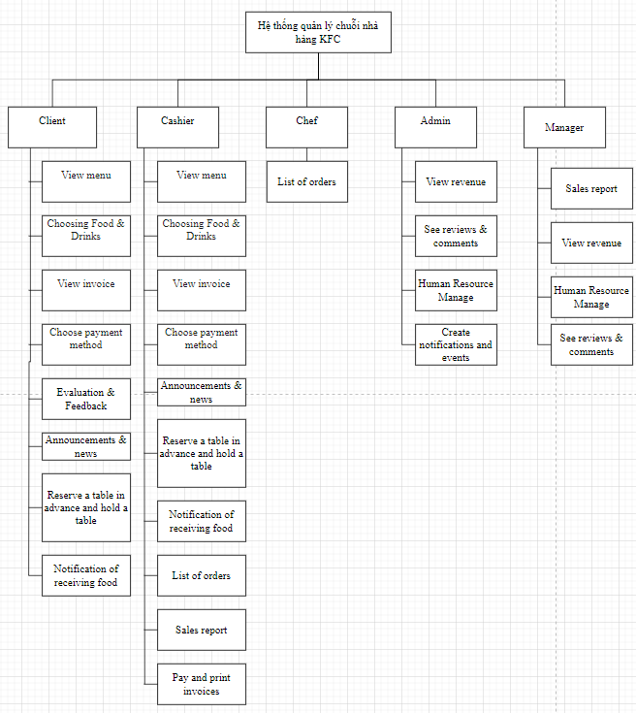

**7.2 Context Model**

**a) Context Model**

<Xây dựng Context Model (System Context Diagram)>

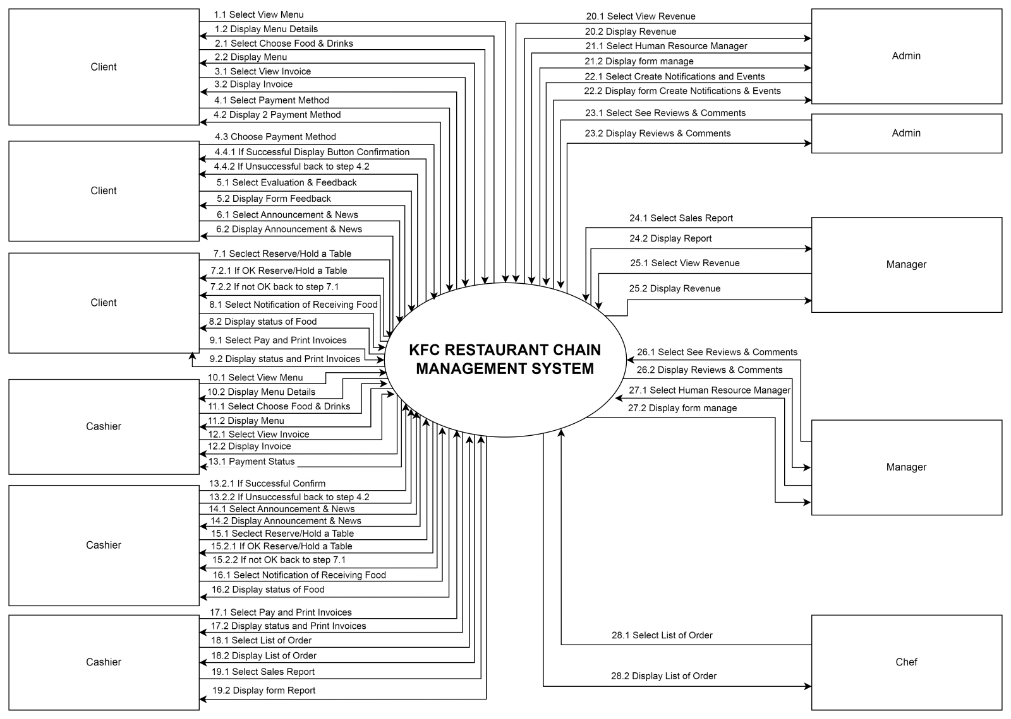

**b) System Context Description**

**7.3 List of Actor**

1. **Client**: People go to restaurants to eat and experience service
2. **Cashier**: Manager of financial transactions, orders, invoices, and payment processing
3. **Chef**: The person who prepares the dishes
4. **Admin**: People with special access rights manage, monitor and control the entire system
5. **Manager**: Leaders, managers, support staff and solve restaurant problems

**7.4. List of Use Cases**

|  |  |  |
| --- | --- | --- |
| **Use case ID** | **Use case name** | **Functional Req.** |
| *UC.01* | View menu | *FR1.1* |
| *UC.02* | Choosing Food & Drinks | *FR1.2* |
| *UC.03* | View invoice | *FR1.3* |
| *UC.04* | Choose payment method | *FR1.4* |
| *UC.05* | Evaluation & Feedback | *FR1.5* |
| *UC.06* | Announcements & news | *FR1.6* |
| *UC.07* | Reserve a table in advance and hold a table | *FR1.7* |
| *UC.08* | Notification of receiving food | *FR1.8* |
| *UC.09* | Pay and print invoices | *FR1.9* |
| *UC.10* | List of orders | *FR2.0* |
| *UC.11* | Sales report | *FR2.1* |
| *UC.12* | View revenue | *FR2.2* |
| *UC.13* | Human Resource Manage | *FR2.3* |
| *UC.14* | Create notifications and events | *FR2.4* |
| *UC.15* | See reviews & comments | *FR2.5* |

**8. PROJECT PLAN**

|  |  |  |  |  |  |
| --- | --- | --- | --- | --- | --- |
| **No.** | **Task Name** | **Duration (Days)** | **Start** | **Finish** | **Assign to** |
| **1** | **Initial** | **7** | **20/08/2022** | **26/08/2022** | **Nhan, Tuan, Huy, Huy** |
| 1.1 | Project Kick-off Meeting | 1 day | 20/08/2022 | 20/08/2022 | Nhan,Tuan,Huy,Huy |
| 1.2 | Discuss about project ideal | 1 day | 21/08/2022 | 21/08/2022 | Nhan,Tuan,Huy,Huy |
| 1.3 | Create Proposal Document | 1 day | 22/08/2022 | 22/08/2022 | Nhan,Tuan,Huy,Huy |
|  |  |  |  |  |  |

**9. TECHNICAL CONSTRAINTS**

**9.1 Technical to develop:**

* ***Languages****: Python, java, java scrip, c++*

**9.2 Environment:**

* ***Environment:*** *IOS*

**9.3 Another:**

* ***Management tool****: Github*
* ***Design tool****: Figma*
* ***Test tool*** *: Excel*

**10. ANALYSIS & MODELING REQUIREMENT**

**10.1. Use Case Diagram**

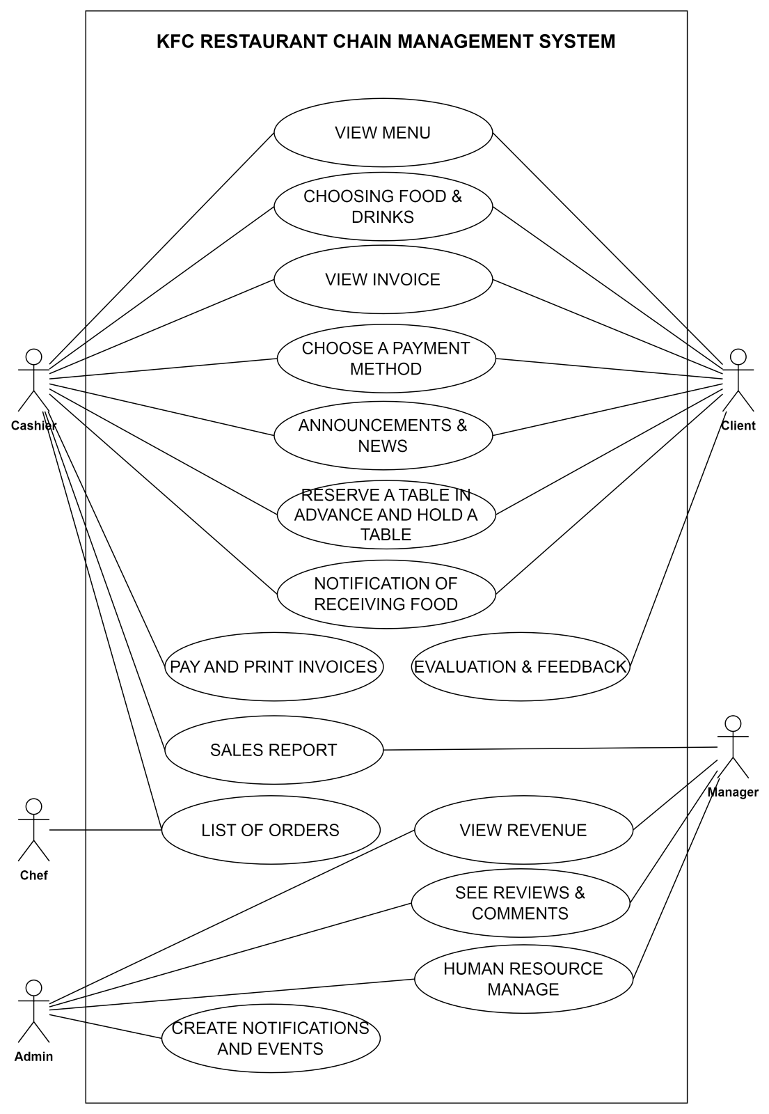

**10.2. List of Business Rule**

|  |  |  |
| --- | --- | --- |
| **Code** | **Business rules** | **Use case** |
| *BR1* | *Dùng thẻ giảm giá để giám giá theo nội dung của mã* | *UC.09* |
| *BR2* | *Mỗi thẻ giảm giá chỉ dùng 1 lần* | *UC.09* |
| *BR3* | *Mỗi đơn hàng chỉ có thể tối đa áp dụng 1 thẻ giảm giá* | *UC.09* |
| *BR4* | *Thẻ giảm giá chỉ được phát khi có thông báo* | *UC.15* |

**10.3. Activity Diagram**

**a) The steps performed of function abc….**

*<Mô tả các bước thực hiện trên mỗi chức năng cho 5 chức năng (chọn bất kỳ).*

* **Steps performed of function: View Menu**

|  |  |
| --- | --- |
| **Client** | **System Response** |
| **1. Touch the “View Menu” button** | **2. Display menu with description of ingredients, prices, cooking time in full screen** |
| **3. Touch the “Close” button** | **4. Close the “View Menu”** |

* **Steps performed of function: Choosing Food & Drinks**

|  |  |
| --- | --- |
| **Client/Cashier** | **System Response** |
| **1. Touch the “Choosing Food & Drinks” button** | **2. Display the menu in full screen** |
| **3. Touch the image of the desired dish and enter the quantity (note if necessary)** | **4. Create invoices, display a list of orders and amounts to be paid** |
| **5. Touch the “Close” button** | **6. Close the “Choosing Food & Drinks”** |

* **Steps performed of function: View Invoice**

|  |  |
| --- | --- |
| **Client/Cashier** | **System Response** |
| **1. Touch the “View Invoice” button** | **2. Display details of customer invoices ordered recently** |
| **3. Touch the “Close” button** | **4. Close the “View Invoice”** |

* **Steps performed of function: Choose Payment Method**

|  |  |
| --- | --- |
| **Client/Cashier** | **System Response** |
| **1. Touch the “Choose Payment Method” button** | **2. Display 2 payment methods (cash, e-wallet)** |
| **3. Choose 1 of 2 payment methods** | **4. 1. If the payment method is cash, the system displays a “Successful payment confirmation” button**  **2. If the payment method is an e-wallet, the system automatically checks the transaction status of the order. If the transaction is successful, the system displays a successful payment confirmation button, otherwise the system displays an error message and returns to step 2.** |
| **5. Touch the “Successful payment confirmation” button** | **6. If there is a promotion program, the system will refund part of the order value to the customer, otherwise the system will move to step 7.** |
| **7. Touch the “Close” button** | **8. Close the “Choose Payment Method”** |

* **Steps performed of function: Announcements & news**

|  |  |
| --- | --- |
| **Client/Cashier** | **System Response** |
| **1. Touch the “Announcements & news” button** | **2. Displays notification titles, news, and the time they were created** |
| **3. Choose notifications to view** | **4. Show notification details** |
| **5. Touch the “Close” button** | **6. Close the “Announcements & news”** |

**b) Activity Diagram of function abc….**

*<Xây dựng active diagram cho 5 chức năng đã chọn ở trên.>*

* **Activity Diagram of function: View Menu**

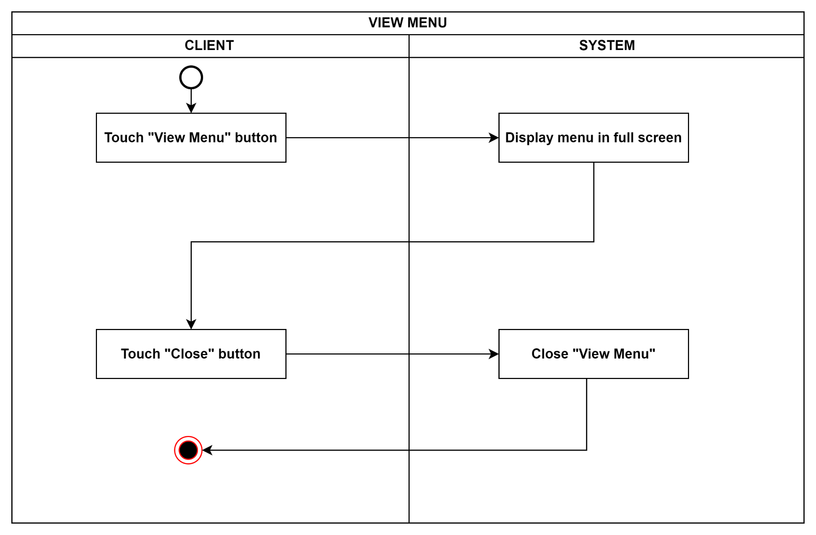

* 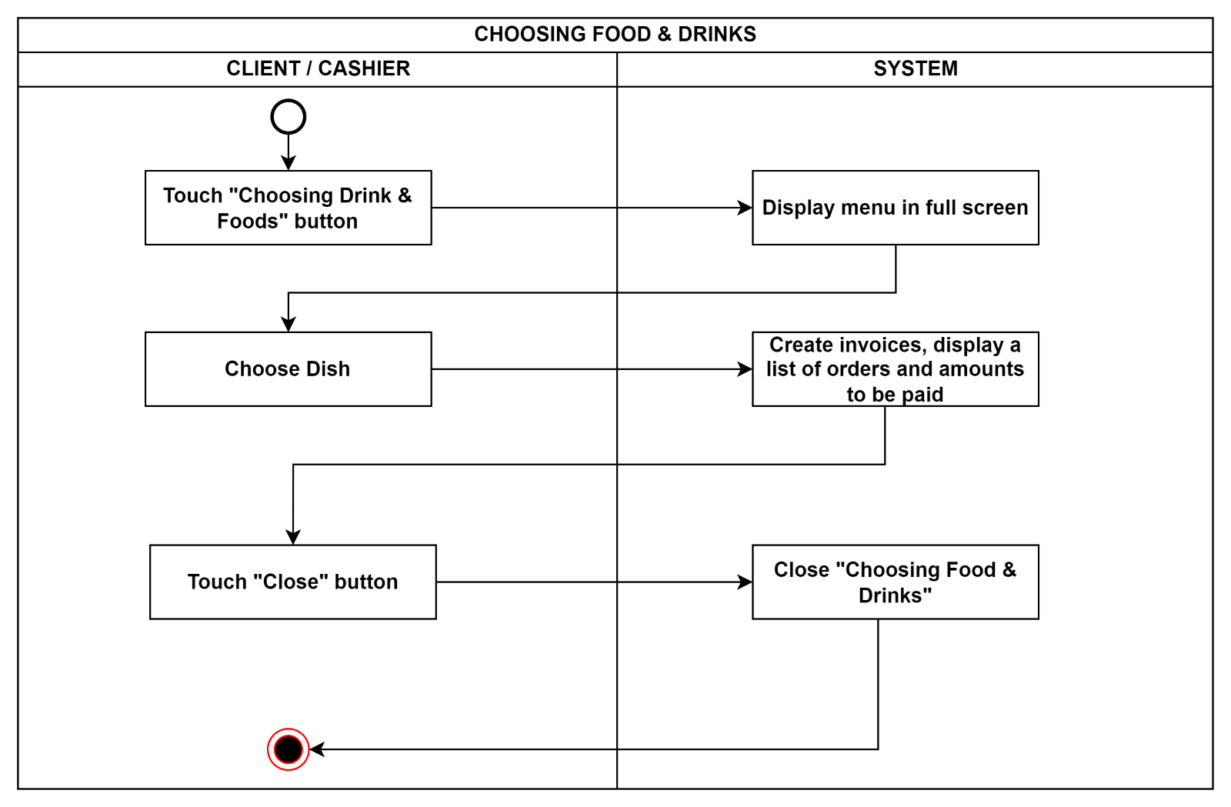**Activity Diagram of function: Choosing Food & Drinks**

* 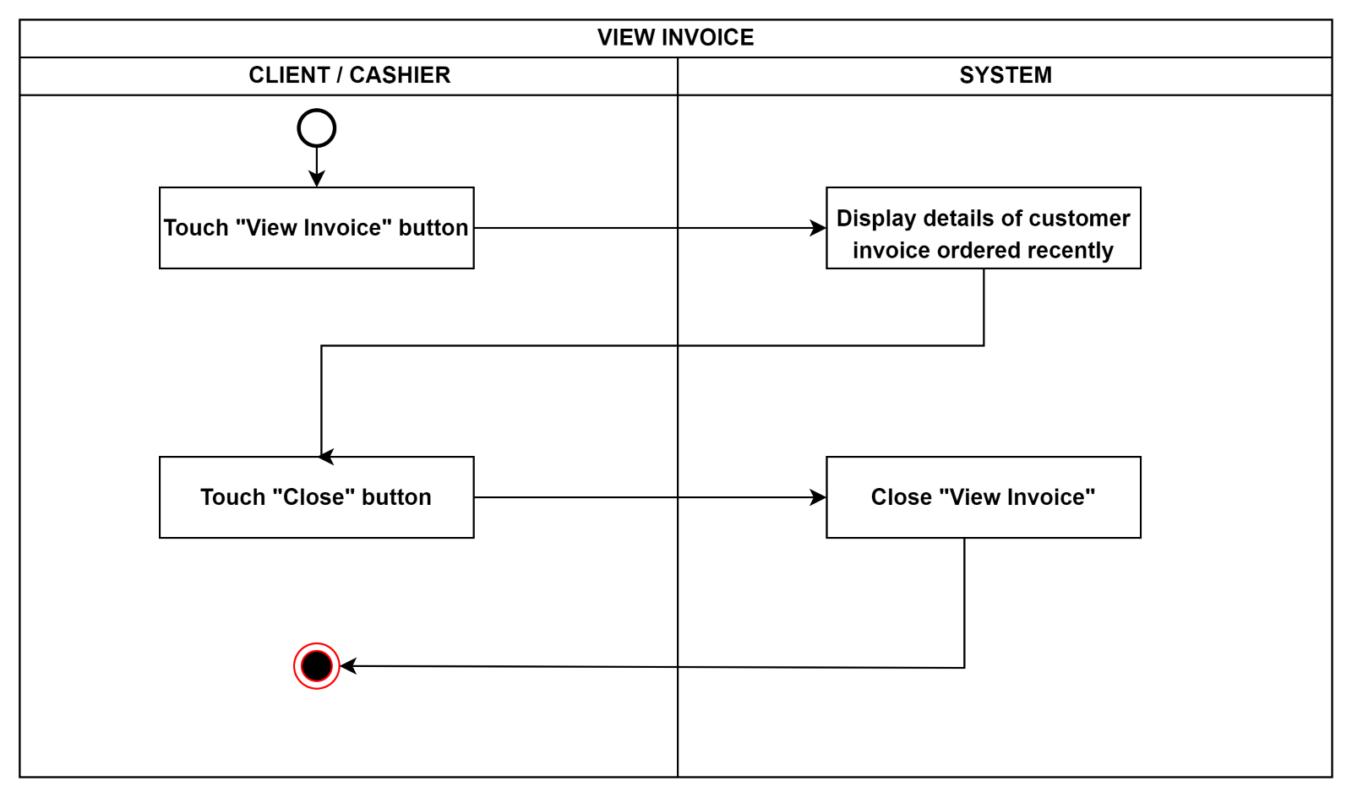**Activity Diagram of function: View Invoice**

* 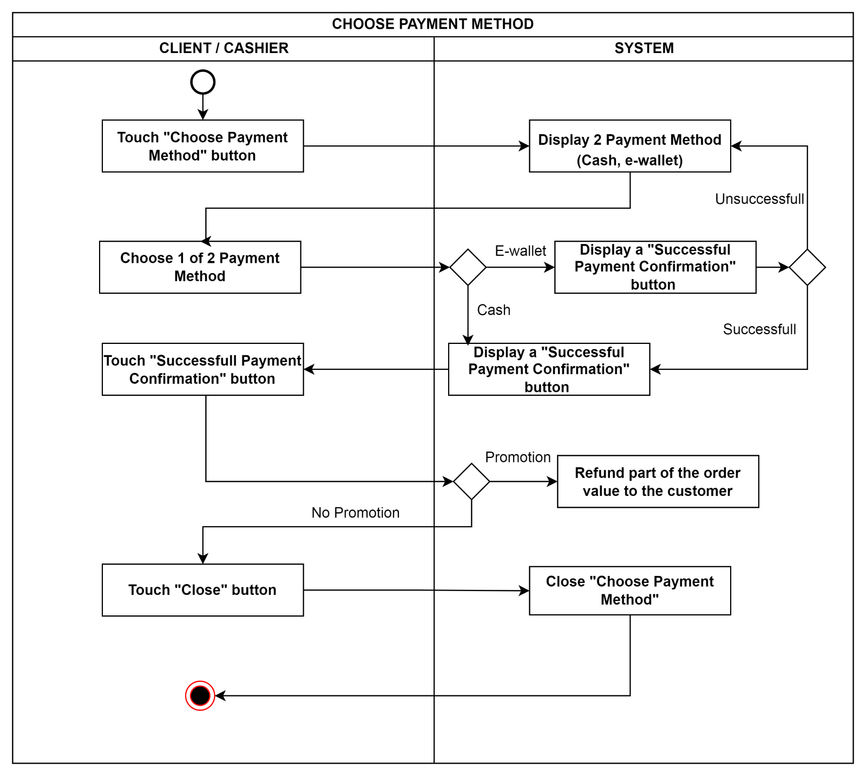**Activity Diagram of function: Choose Payment Method**

* 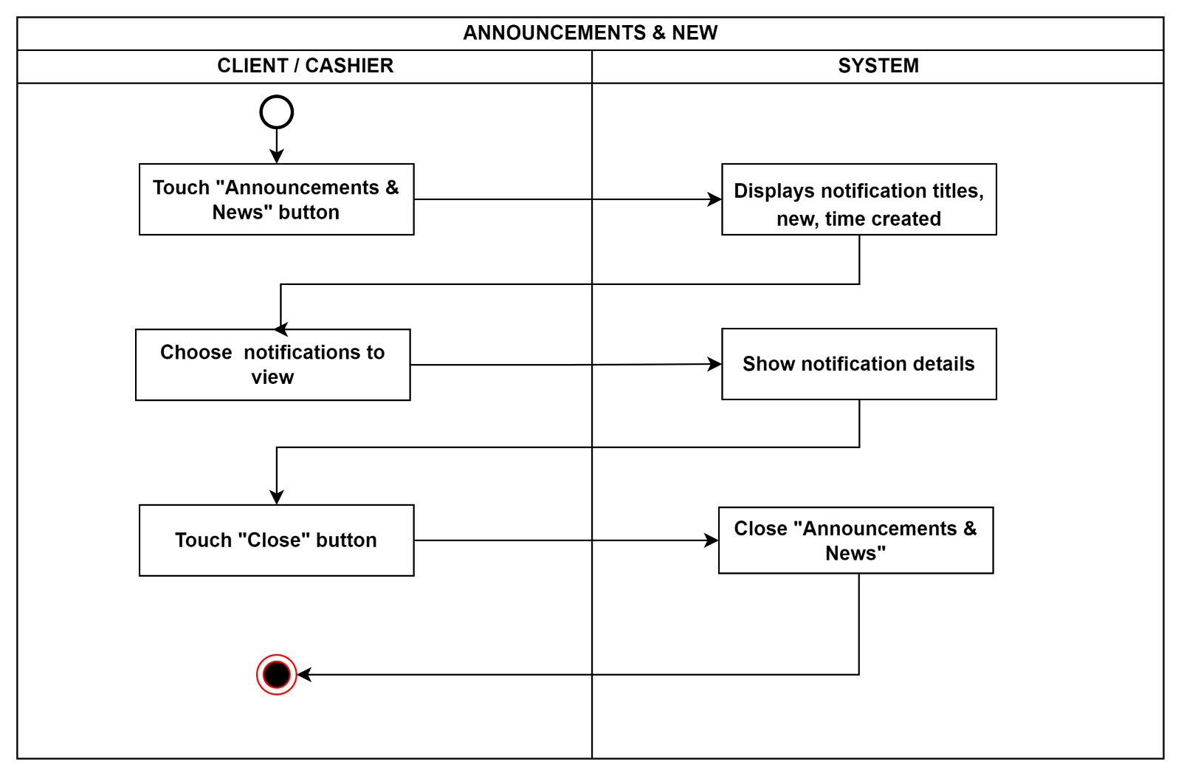**Activity Diagram of function: Announcements & news**

**11. INTERFACE DESIGN**



**11.1. Introduction tool design**

*Figma is a web-based application with a variety of powerful design tools. With Figma, you can create unlimited user interface (UI/UX) designs, prototype design projects. We have also used Figma to design software interfaces and design functional interfaces for systems.*

**11.2 User Interface Design for ABC Function**

Giao diện chọn chức năng:

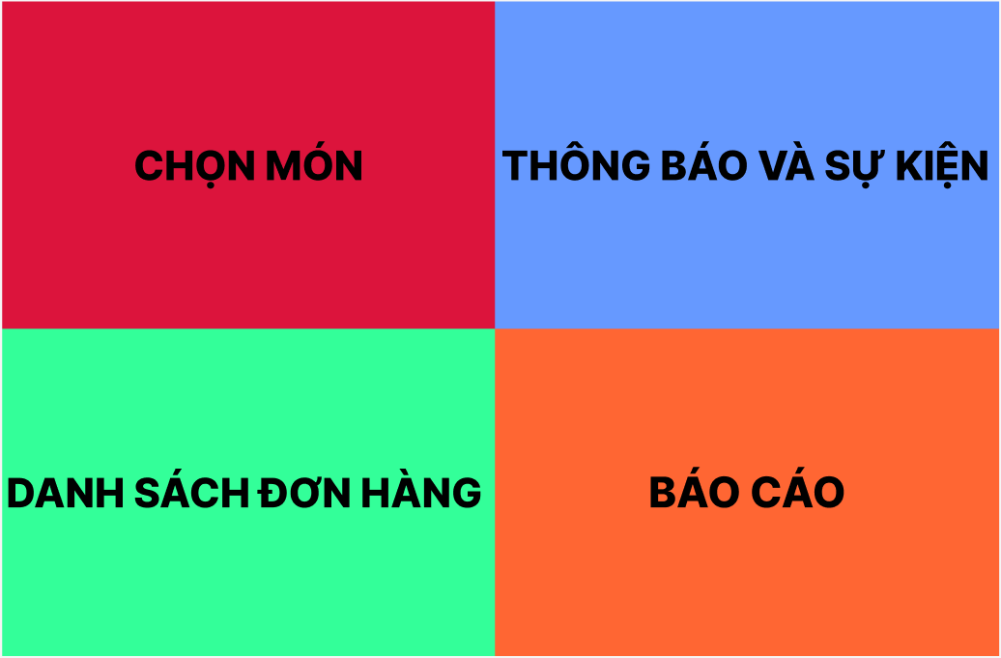

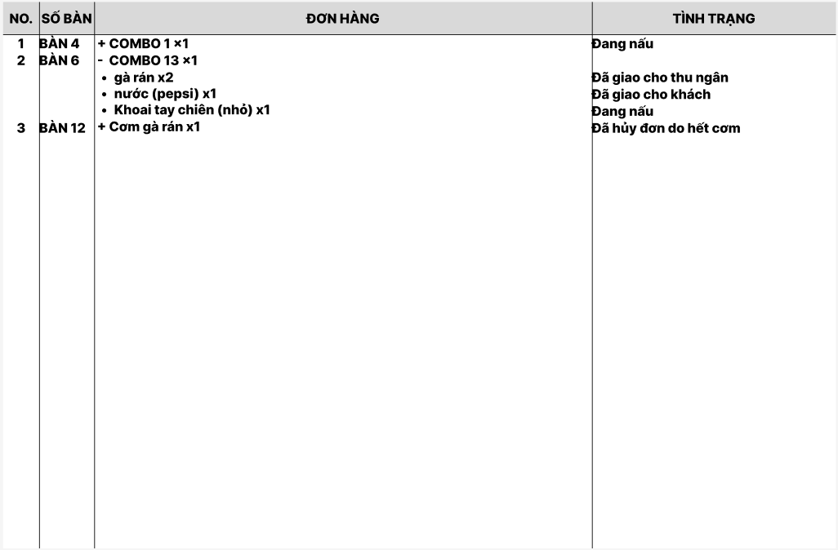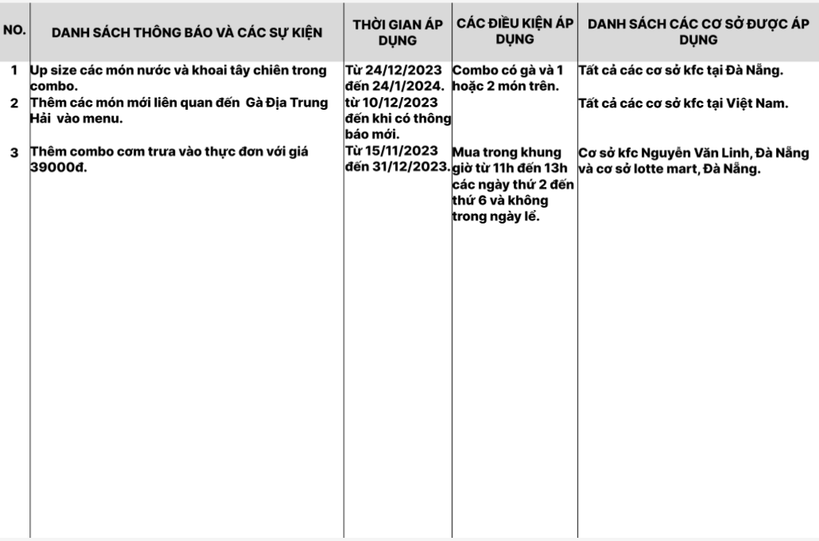Giao diện chức năng báo cáo:

Giao diện chức năng xem danh sách đơn hàng:

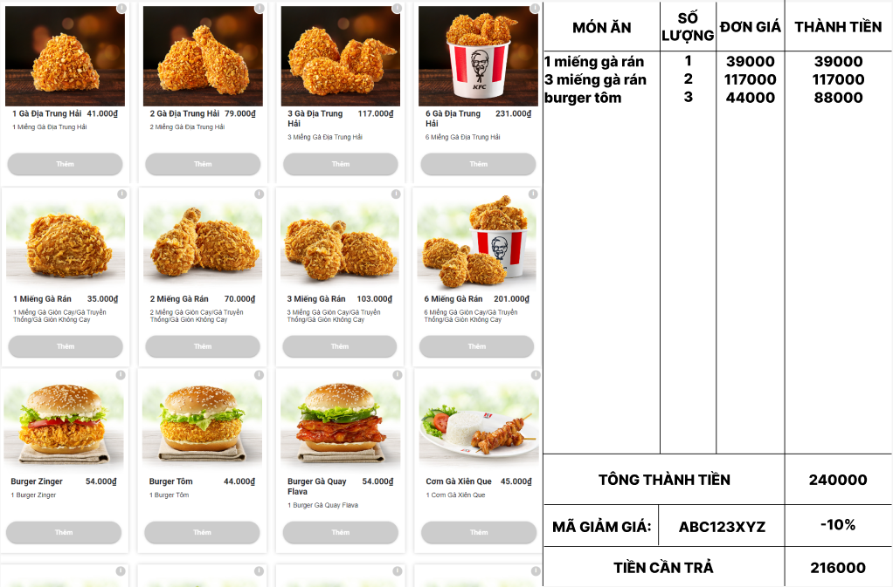Giao diện chức năng chọn món và thanh toán:

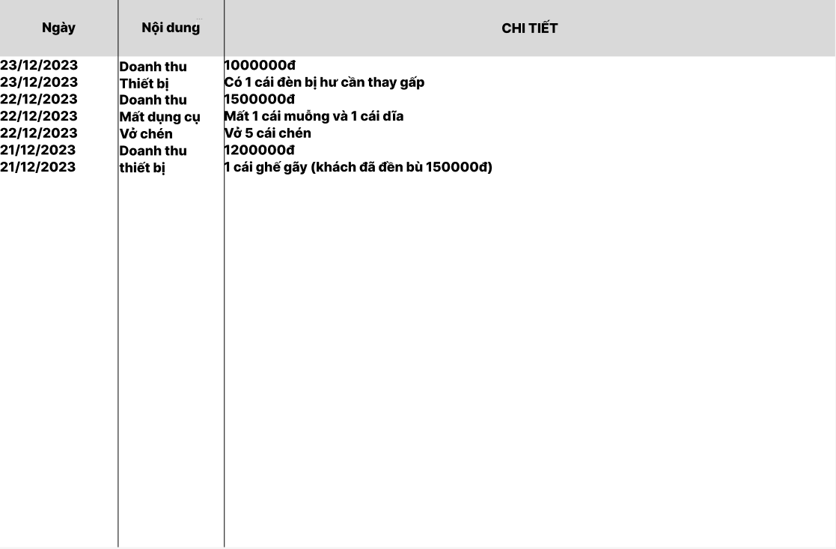Giao diện chức năng báo cáo:

**12. CONFIGURATION MANAGEMENT**

**a) Introduction the tool Source Code Management**

* *Git Hub is a web-based code hosting servide that use the git version control system. Git hub allows developer to store, share, and collaborate on their code in a secure and efficient way.*

**b) Introduction Key Functional**

* ***Code hosting****: Git hub provides a secure and reliable and repository to store user code. User can create private or public repository, depending on user need.*
* ***Version control****: Git Hub uses the git version control system to track changes to user code. This made it easy to restore previous versions of user code and track the changes that have been made.*
* ***Collaboration****: Git hub allows you to collaborate with other developers on the same project. User can share they code with others and see their changes.*

**c) The Screen Shot apply Source Code Management of team**

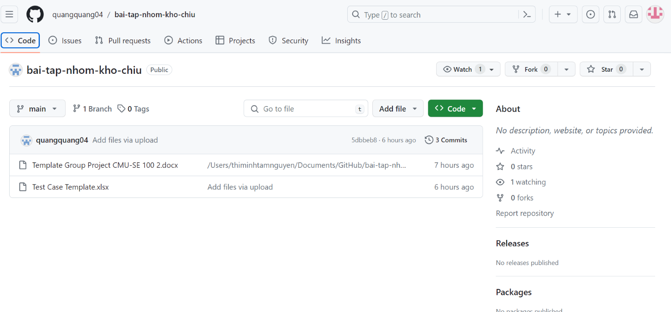

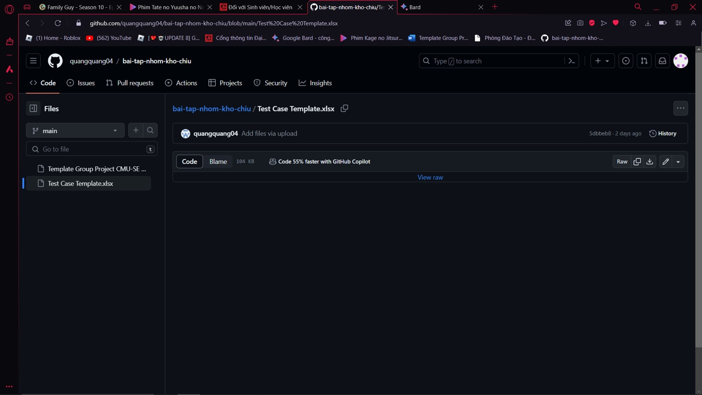

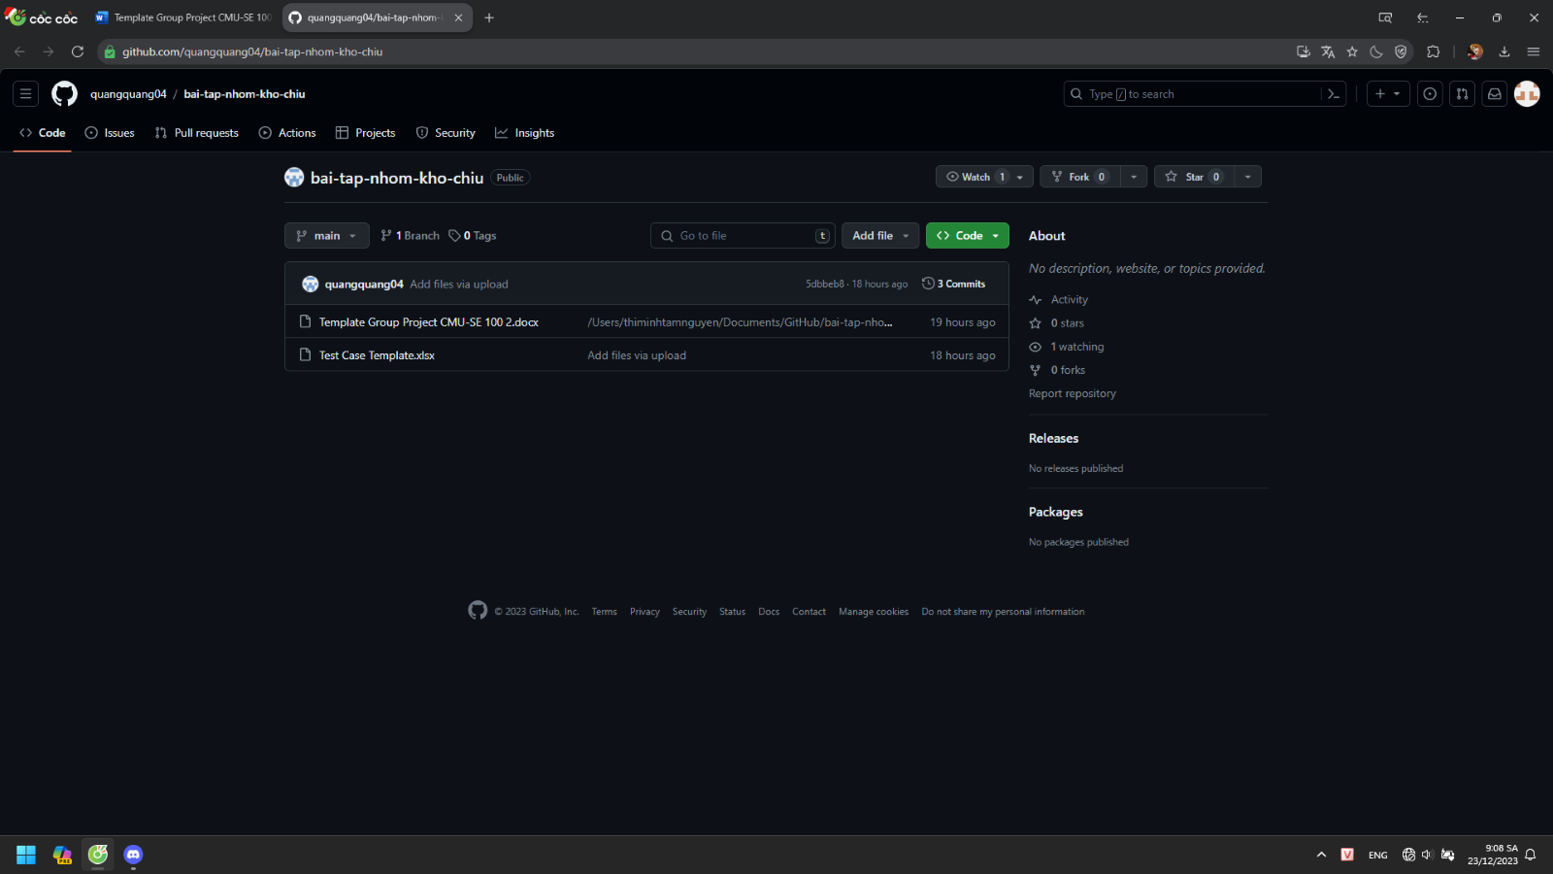

**13. TESTING**

**a) Introduction to method testing apply of this project**

*<Giới thiệu phương pháp kiểm thử được áp dụng cho dự án>*

**b) Test Cases**

*<Thiết kế test case cho các chức năng (05 chức năng bất kỳ), theo mẫu Test Case đính kèm>*

**14. CONTRIBUTION**

*<Team member contributed significantly to team's success (%)>*

|  |  |  |  |  |
| --- | --- | --- | --- | --- |
| **No.** | **Participant**  *<Họ tên>* | **Role**  *<Vai trò>* | **Responsibilities**  *<Trách nhiệm cụ thể được phân công, đóng góp cho bài tập nhóm>* | **%**  *Mức độ (%) đóng góp cho bài tập nhóm* |
| **1** | **Đặng Nguyễn Nhật Quang** | **Team leader** | **Phân công, theo dỏi deadline, làm các mục 11.2,̃ 7.1, 7.3, 7.4, 1, 6.3.** | 100% |